SECTION 32 17 13
PARKING BUMPERS

PART 1 GENERAL
- SECTION INCLUDES:
  - Precast concrete, recycled plastic, or recycled composite parking bumpers and anchorage.
- REFERENCES
  - ASTM A615/A615M - Standard Specification for Deformed and Plain Carbon Steel Bars for Concrete Reinforcement
  - ASTM C33/C33M - Standard Specification for Concrete Aggregates
  - ASTM C150/C150M – Standard Specification for Portland Cement
  - ASTM C260/C260M - Standard Specification for Air-Entraining Admixtures for Concrete
  - ASTM C330/C330M - Standard Specification for Lightweight Aggregates for Structural Concrete
- SUBMITTALS FOR REVIEW
  - Section 01 30 00 Submittals: Procedures for submittals
  - Product Data: Provide unit configuration, dimensions

PART 2 PRODUCTS
- CONCRETE BUMPERS
  - Cement: ASTM C150/C150M, Portland Type I - Normal gray color
  - Concrete materials: ASTM C33/C33M water and sand
  - Reinforcing Steel: ASTM A615/A615M deformed steel bars; galvanized finish, strength, and size commensurate with precast unit design
  - Air Entrainment Admixture: ASTM C260/C260M
  - Concrete Mix: Minimum 3500 psi, 28-day strength, air entrained 5% to 7%
  - Use rigid molds, constructed to maintain precast units uniform in shape, size, and finish.
    - Maintain consistent quality during manufacture.
  - Embed reinforcing steel, and drill or sleeve for two dowels.
  - Cure units to develop concrete quality, and to minimize appearance blemishes such as non-uniformity, staining, or surface cracking.
  - Minor patching in plant is acceptable, providing appearance of units is not impaired.
- RECYCLED PLASTIC/COMPOSITE
  - Color to be gray.
  - Recycled Plastic: Recycled plastic, solid wheel stops.
  - Recycled Composite: As manufactured by Xpotential Products, or equal.
  - Provide minimum five-year product warranty.
  - Products shall be chemical and weather resistant.
- CONFIGURATION
  - Concrete: Use the FDOT standard wheelstop, refer to FDOT Index 520-001, sheet 2 of 2. Also refer to the detail at the end of this section.
  - Recycled Profile: Pentagonal section, non-equilateral, nominal size of 4" H x 6" W x 6' L.
- ACCESSORIES
  - Concrete Stops: Dowels, 2 per stop-Steel, #4 rebar (½" diameter), 18" long.
  - Recycled Plastic or Composite: Use manufacturers required fasteners, at minimum provide 2-galvanized steel dowels ½" diameter x 18" long per stop.

PART 3 EXECUTION
- INSTALLATION
  - Set wheel stop with anchors at each parking space as shown on the plans.
    - Grout bottom as required for firm bearing.
    - Install units without damage to shape or finish, replace or repair damaged units.
    - Install units in alignment with adjacent work.
    - Fasten units in place with two anchors per unit bumper.
    - Drive anchors to within 1" of top surface of wheel stop, then using a setting tool drive anchor at least ¼ inch below top of stop and then grout or caulk opening.

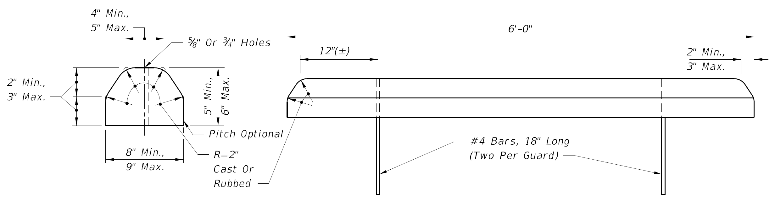

FDOT STANDARD CONCRETE WHEEL STOP

END OF SECTION

